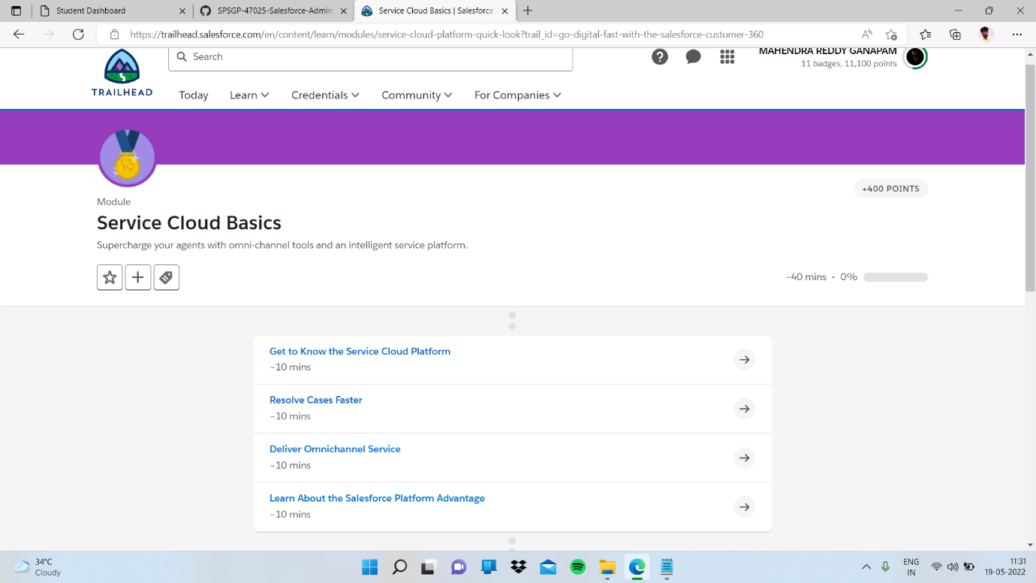

Sub topic:- Learn About the Salesforce Platform Advantage

In this I completed quiz

